**Name: HAMMAD TAHIR**

**Intern ID: TN/IN01/PY/006**

**Email ID : BEINGHAMMAD345@GMAIL.COM**

**Internship Domain : PYTHON**

**Task Week : 04**

**Instructor Name : HASSAN ALI**

**Task 1 :**

Ask user to input any value. Use type() to check its data type. Use exec() to execute a string as Python code.

**Solution:**

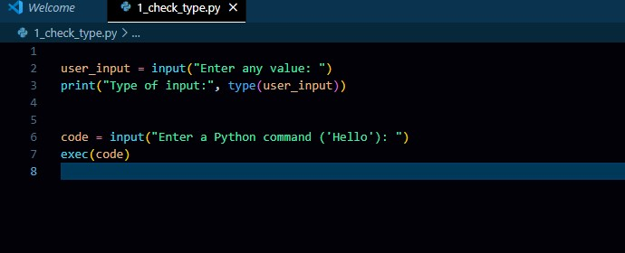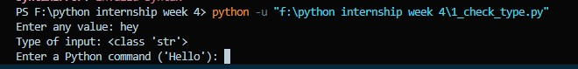

**Task 2 :**

Ask user for a Python expression as a string (like '2 + 3 * 4') and evaluate it using exec(). Show result.

**Solution:**

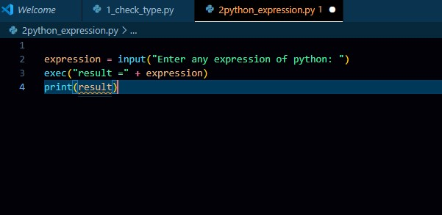

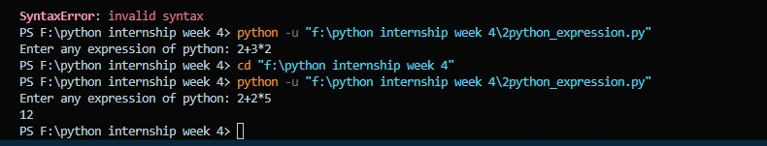

**Task 3:**

Use math module to take a radius input from user and calculate:

- Area of circle, circumference, and square root of area.

**Solution:**

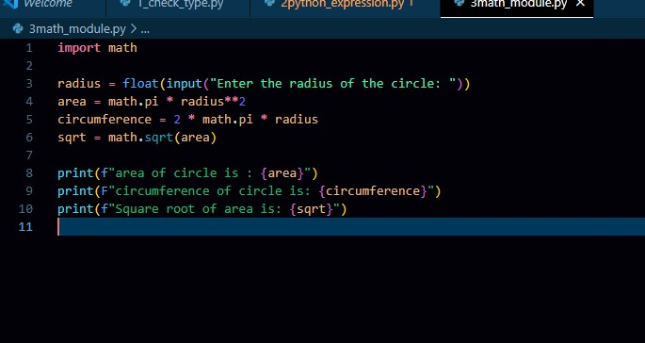

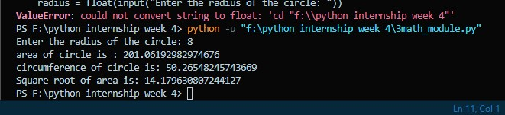

**Task 4:**

Use random module to generate a random 8-character password using letters, numbers, and symbols.

**Solution:**

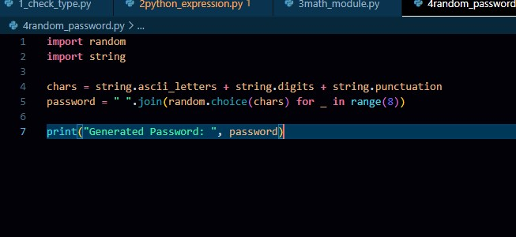

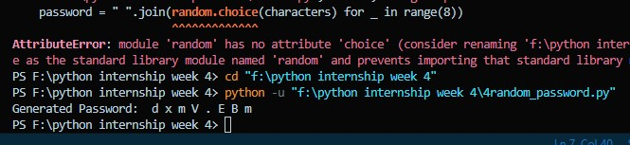

**Task 5:**

Using datetime module, ask user for their birth date and show:

- Their age in years and number of days lived.

**Solution:**

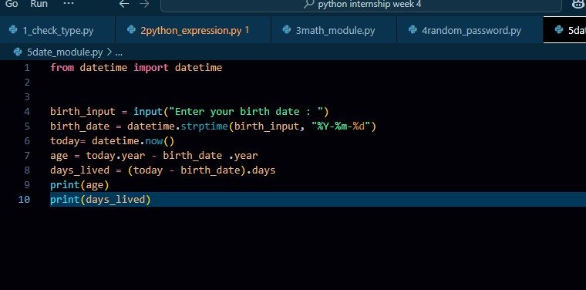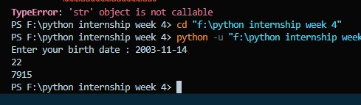

**Task 6:**

Create a script using os and re that lists all `.txt` files from a folder and filters only those that match a pattern (e.g., start with 'report').

**Solution:**

